**ASSIGNMENT 1 FRONT SHEET**

|  |  |  |  |
| --- | --- | --- | --- |
| **Qualification** | **BTEC Level 5 HND Diploma in Computing** | | |
| **Unit number and title** | Unit 06: Managing a Successful Computing Project | | |
| **Submission date** |  | **Date Received 1st submission** |  |
| **Re-submission Date** |  | **Date Received 2nd submission** |  |
| **Student Name** | Bùi Hương Linh | **Student ID** | GBH200662 |
| **Class** | GCH1002 | **Assessor name** | Đỗ Tiến Thành |
| **Student declaration**  I certify that the assignment submission is entirely my own work and I fully understand the consequences of plagiarism. I understand that making a false declaration is a form of malpractice. | | | |
|  |  | **Student’s signature** |  |

**Grading grid**

|  |  |  |  |  |  |  |
| --- | --- | --- | --- | --- | --- | --- |
| P1 | P2 | P3 | P4 | M1 | M2 | D1 |
|  |  |  |  |  |  |  |

|  |  |  |
| --- | --- | --- |
| **❒ Summative Feedback: ❒ Resubmission Feedback:** | | |
| **Grade:** | **Assessor Signature:** | **Date:** |
| **IV Signature:** | | |

Table of Contents

I. Introduction 4

II. Project Plan 4

1. Scope 4

2. Project Objectives 5

3. Project schedule (Gantt Chart) 5

4. WBS 6

5. Human resources 7

6. Budget 8

7. Risk plan 8

8. Project communication 9

III. Qualitative and quantitative research 13

1. Hypotheses 13

2. Interview 14

3. Survey 14

4. Findings of research 19

IV. Conclusion 21

References 21

1. Introduction

Currently, the problem of air and environmental pollution is increasing over time. According to the information I find, Vietnam is classified as one of the countries with the highest amount of waste in the world. Therefore, in this report, the author will plan to build a project to develop plastic waste recycling. Some plans will discuss such as scope, WBS, budget, risks,....

1. Project Plan
2. Scope

Currently, the problem of air and environmental pollution is increasing over time. According to the information I find, Vietnam is classified as one of the countries with the highest amount of waste in the world.

Especially because awareness of the dangers of plastic waste is still incomplete, there are still many individuals who have the habit of littering indiscriminately or not classifying waste at the source, leading to plastic pollution. Therefore, the reality of plastic waste pollution causes many negative and heavy impacts directly on the living environment of organisms and humans.

Secondly, the treatment of plastic waste in Vietnam still has many shortcomings, most of which are disposed of by burying; only 10% of it is recycled. Meanwhile, plastic waste is very difficult to decompose in the natural environment.

So, in order to minimize the environmental pollution, I decided to create a website about recycling called "Green Environment" and spread the word to everyone to "Separate and recycle plastic products that are still usable."

My goal when doing this "Green Environment" is to reduce environmental pollution, buy recyclable things to resell to everyone, and help people limit the use of non-biodegradable things.

The "Green Environment" project has a clear and easy operation process for users.

First, the 'Green environment' is divided into three parts: To store information about products before recycling (only admin has access), customer information (only admin has access) and information - the price of the product when it is recycled (can be viewed by both admins and users).

To store recycled product information, we need to classify products into appropriate groups. After sorting the products, the admin will save the information in the database so that the staff can easily control the products every time they are recycled.

After the product is successfully recycled, it will push the product into the "Green Environment" application, which is an important part of the working cycle. Because after the product is recycled, the administrator will check it and then push it up. Admin will have the right to add, edit, and delete products.

When entering the application, the user will see product information and the price of the product after being recycled, information on where to receive recyclables and partners, as well as how to contact "Green Environment."

I connected to MGreen in order to test the "Green Environment" app. I want to bring this "Green Environment" closer to users. Let people know that plastic waste is also recyclable. This trial will take place within six months, from advocacy to sorting garbage for recycling to successful recycling and being put into the "Green Environment" application.

According to MGreen's report, using this "Green Environment" application is not difficult and very easy to use. "Thanks to it, the production process is easier, saving time, and employees can easily grasp the work and reduce the amount of waste that goes outside," MGreen said. About 4 months after the customer used the "Green Environment" application, it brought me 2 billion VND in revenue. "Green Environment" has received a lot of positive feedback from customers about the product, not only for its reasonable price but also for being very useful for daily life.

After looking at the website of MGreen, I see a lot of interesting things to apply to my 'Green Environment' application:

Create many projects related to the recycling of plastic waste.

100% of profits to be reinvested into society.

Recycling plastic waste not only helps save and protect natural resources, but also helps your family save money on buying items. Besides, recycling also helps to protect and minimize the problem of environmental pollution.

Our project is to implement a plastic waste recycling website, but there is no support application for smartphones yet. I will try to develop software for this on smartphones.

1. Project Objectives

**Attract users** - I hope that this project will succeed, attract a large number of customers, and assist people in reducing the amount of waste in the environment, thereby assisting the environment to be green, clean, and attractive to many visitors.

**User behavior** - Customers are already aware of the "Green Environment" application due to its ability to mobilize and spread, and thanks to the application, environmental pollution is reduced. People are becoming more environmentally conscious; instead of throwing things away, we can sort and recycle them into items that improve our lives.

**Effectiveness** - Plastic waste recycling is still uncommon, and plastic waste collection and classification are critical in today's world. As a result, it is hoped that this project will help to protect the environment and reduce pollution.

1. Project schedule (Gantt Chart)

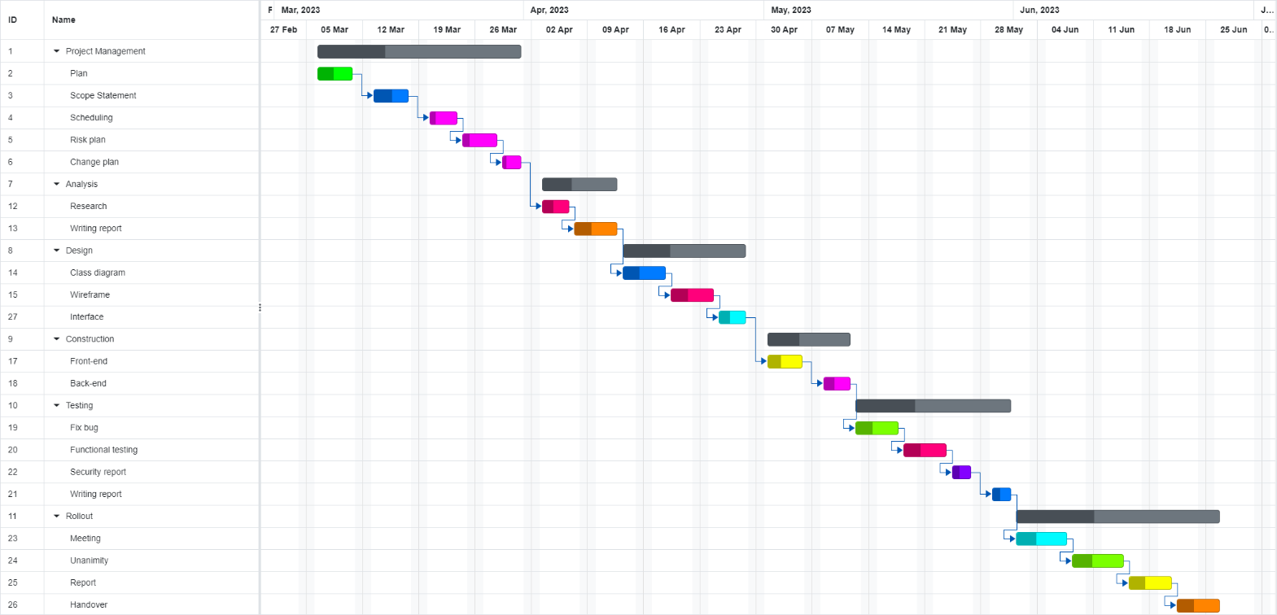

1. WBS

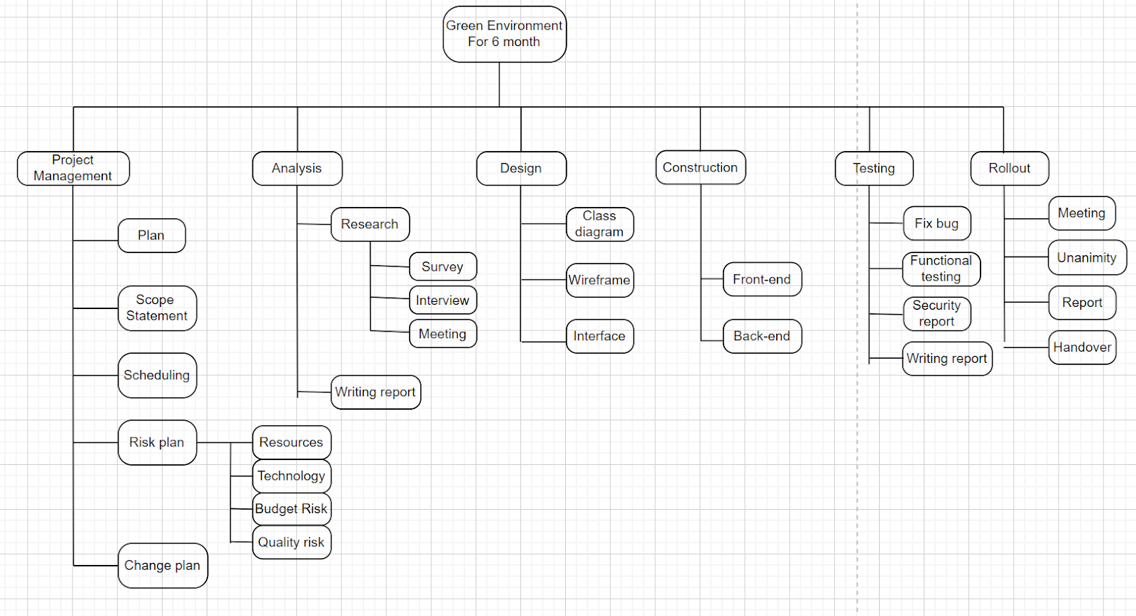

1. Human resources

|  |  |  |
| --- | --- | --- |
| Squad/Team/Human a resource | Role/Responsibility/Tasks | Quantity |
| Project manager | Managing team member.  Control scope and risk, quality.  Reporting status of project.  Project costs.  Equip the necessary skills to complete the project. | 1 |
| Designer | Meet with customers and communicate with them in order to understand their requirements and to assist them in communicating their ideas in the most understandable way possible. Based on the survey results, design the product, and create the project logo. | 2 |
| Coding | They are in charge of creating databases and writing code modules for computer-based software applications and programs. We will maintain the system on a regular basis to ensure that the programs work properly. | 2 |
| Marketing & Sale | Market survey and planning to bring the product to market.  Create images and messages for the project so that it can communicate clearly, accurately, and attract everyone's attention. | 2 |
| Business Analyst | They assist management in analyzing project data and operations, identifying project-related problems, providing direction, and proposing appropriate project solutions. | 1 |

1. Budget

|  |  |  |  |
| --- | --- | --- | --- |
| Type of cost | Project cost | Percentage of overall budget | Budget |
|  | Testing | 8% | $8000 |
|  | Design | 5% | $5000 |
|  | Marketing | 10% | $10000 |
|  | Employee | 3% | $3000 |
|  | Coding | 10% | $10000 |
|  | Risk | 15% | $15000 |
|  | Application development | 5% | $5000 |
|  | Total | $86000 |  |

1. Risk plan

|  |  |  |  |  |
| --- | --- | --- | --- | --- |
| Risk description | Type | Likelihood | Impact | Solution/Mitigation Plan |
| Slow progress | Quality risk | High | Medium | Together discuss  and give ideas to  speed up the work progress. |
| People throw garbage indiscriminately, causing serious environmental pollution. | Resources | High | High | To classify waste according to regulations and recycle. |
| Website functions. | Technology | Medium | High | Regularly check and secure the system well to ensure stability before putting it on the market. |
| Slow machine, lag – the ITer is working hard but inefficiently. | Budget | Medium | High | Use machines with better processing systems or upgrade the RAM or the CPU. |
| An error occurred while reloading the web page. | Quality | Medium | Low | Check and statistics of errors encountered so that they can be handled in a timely manner. |

|  |  |  |  |  |
| --- | --- | --- | --- | --- |
| Risk Description | Type | Likelihood ( kha nang xay ra) | Impact (tac dong) | Solution/Mitigation Plan |
| People throw garbage indiscriminately, causing serious environmental pollution. | Resources | Very high | High | To classify waste according to regulations and recycle. |
| Together discuss and give ideas to speed up the work progress and slow progress. | Quality risk | High | Medium | Give common discipline, unite, discuss, and contribute ideas to accelerate work progress... |
| Hackers steal data or crash systems, causing data to be lost and unrecoverable. | Technology | High | High | Install a good firewall to protect your data, keep your passwords safe, and perform regular backups to keep your website safe from loss. |
| Slow machine, lag – the ITer is working hard but inefficiently. | Budget | medium | high | Use machines with better processing systems or upgrade the RAM or the CPU. |
| When a project is implemented, it is unavoidable that unexpected situations arise, such as: poor health, a tired working spirit, personal problems, and so on. | Resources | Medium | High | We must have a backup plan in place for unexpected events like this so that the project is not delayed for too long. |

1. Project communication

|  |  |  |  |  |
| --- | --- | --- | --- | --- |
| Date | Method | Type | Description | Responsible Team Member |
| **01/01/2023** | Meeting | Project | Group establishment. | All |
| **02/03/2023** | Meeting | Project | Questions related to project selection. | Thiên |
| **05/03/2023** | Meeting | Project | Decide on the project's topic. | All & Leader |
| **10/03/2023** | Meeting | Project | Discuss the project subject that was agreed to by the group. | All |
| **25/03/2023** | Meeting | Project | Provision of Gmail addresses for Creation of Shared Google Drive folder. | All |
| **26/03/2023** | Meeting | Project | Project implementation. | All |
| **26/03/2023** | Meeting | Project | Select the relevant document for the project. | All |
| **07/04/2023** | Meeting | Project | Share project information within the established Google Drive. | All |
| **07/04/2023** | Meeting | Project | Update information regularly for project completion. | All |

|  |  |  |  |  |  |
| --- | --- | --- | --- | --- | --- |
| LH Team Meeting | | | | | |
| **Minutes** | 01/03/2023 | | 5:30 pm | | G408 |
|  | | | | | |
| **Meeting Called by** | Team | | | | |
| **Attendees** | Linh(GBH200662), Thiên(GCH200666), Quân(GCH241042),  Nhi(GDH200158), Thảo(GBH200253), Tuấn(GCH273422), My(GBH167327) | | | | |
| **Absentees** | - | | | | |
| **Minutes** | Linh | | | | |
| Agenda topics | | | | | |
| 10 Min | Team formation | | | |  |
| **Discussion** |  | | | | |
| Group establishment. Group members introduced themselves and exchanged mobile numbers. | | | | | |
| Thien will be the one to establish a Zalo group to enable communication. | | | | | |
| Early stage discussion of project selection. | | | | | |
| **Conclusions** |  | | | | |
| The team has many backgrounds in design, IT, management this will be reflected in the website we intend to create. | | | | | |
|  | | | | | |
| **Action items** | | **Person responsible** | | **Deadline** | |
| Create a Zalo group to begin exchanging plans. | | Thiên | | 01/03/2022 | |
| Read references and review subjects for research. | | All | | 05/03/2023 | |

|  |  |  |  |  |  |
| --- | --- | --- | --- | --- | --- |
| LH Team Meeting | | | | | |
| **Minutes** | 01/03/2023 | | 5:30 pm | | G408 |
|  | | | | | |
| **Meeting Called by** | Team | | | | |
| **Attendees** | Linh(GBH200662), Thiên(GCH200666), Quân(GCH241042),  Nhi(GDH200158), Thảo(GBH200253) | | | | |
| **Absentees** | Tuấn(GCH273422), My(GBH167327) | | | | |
| **Minutes** | Linh | | | | |
| Agenda topics | | | | | |
| 10 Min | Briefing topic selection | | | |  |
| **Discussion** |  | | | | |
| Select topics based on the summaries that people provide. Agree on and discuss the selected subject. Nhi suggested that everyone provide a Gmail address so that might create a Google Drive folder for the group so that everyone pushes documents upwards. | | | | | |
|  |
|  |
| **Conclusions** |  | | | | |  |
| Thiên - Risk Recovery Planning  Nhi - Website Design  Thảo - Create database for website  Linh - Write code  Quân - Write source code CSS and HTML | | | | | |  |
| **Action items** | | **Person responsible** | | **Deadline** | |  |
| Thien will provide some common risks before embarking on the project. | | Thiên | | 05/03/2023 | |  |
| Nhi will plan the interface design for the website. | | Nhi | | 06/03/2023 | |  |
| Linh and Quan discuss the code and arrange it properly. | | Linh & Quan | | 10/03/2023 | |  |

|  |  |  |  |  |  |
| --- | --- | --- | --- | --- | --- |
| LH Team Meeting | | | | | |
| **Minutes** | 25/3/2023 | | 6:30pm – 7:30pm | | G410 |
|  | | | | | |
| **Meeting Called by** | Team | | | | |
| **Attendees** | Linh(GBH200662), Thiên(GCH200666), Thảo(GBH200253), Tuấn(GCH273422), My(GBH167327), Quân(GCH241042), Nhi(GDH200158) | | | | |
| **Absentees** | - | | | | |
| **Minutes** | Thiên | | | | |
| Agenda topics | | | | | |
| 60 MIN | Project Review | | | |  |
| **Discussion** |  | | | | |
| This meeting will focus on the project so that it is completed on time, and all team members agree to finish the draft by 11pm this evening, 05/06/2023, and then close the project's final draft by 08/08/2023. | | | | | |
| 1. Group Participation   Thien completed a recording of her interview and contributed to the team's manuscript. Thien also took on the task of completing the minutes of this meeting. Team members have confirmed Thien's contributions in meetings and also hope he will continue to provide information to complete the project soon. Ling also told the group members that if anyone needs help, feel free to ask.   1. Risk Management Plan   Linh stated that she had created a risk management plan for team members to read and comprehend the issue. The plan was approved by the team members, and Linh will expand and review the risk plan's implementation throughout the project.   1. Next Meeting   Nhi booked meeting room number 8 on the 4th floor of Smart City apartment for team members to complete the final report on March 26, 2023, from 3-5 pm. | | | | | |
|  | | | | | |
| **Conclusions** |  | | | | |
| The team has completed the assigned work and will try to implement the project as soon as possible. | | | | | |
| **Action items** | | **Person responsible** | | **Deadline** | |
| First draft of final report sections | | Thiên | | 27/03/2023 | |

1. Qualitative and quantitative research
2. Hypotheses

* By providing an easy-to-use platform for recycling plastic waste, more people will be motivated to participate in recycling efforts, leading to a reduction in plastic pollution.
* Through partnerships with other organizations and companies, "Green Environment" can expand its reach and impact, raising awareness about plastic waste and promoting sustainable behavior.
* By reinvesting 100% of profits into society, "Green Environment" will gain the trust and support of customers who prioritize social and environmental responsibility.

1. Interview

* How do you believe that the "Green Environment" platform will motivate more people to recycle?

What steps have you taken to ensure that the platform is easy to use for all users?

* How will partnerships with other organizations and companies enhance the impact of the "Green Environment" platform?

What criteria will you use to select potential partners?

* What inspired you to reinvest 100% of profits from the "Green Environment" platform back into society?

How do you believe this will impact customer trust and support for the platform?

1. Survey

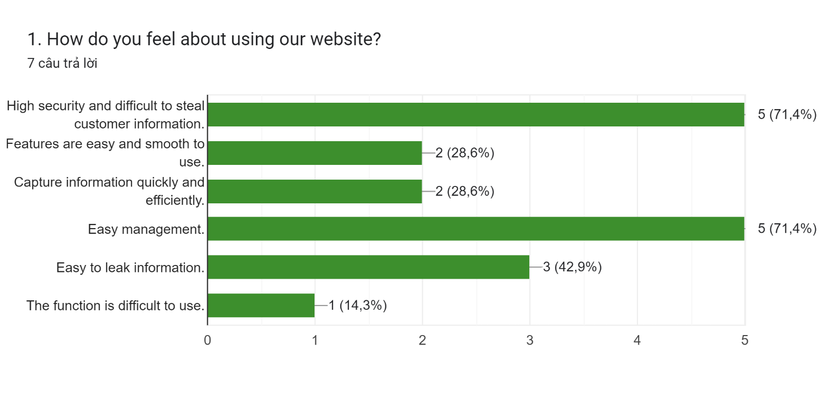

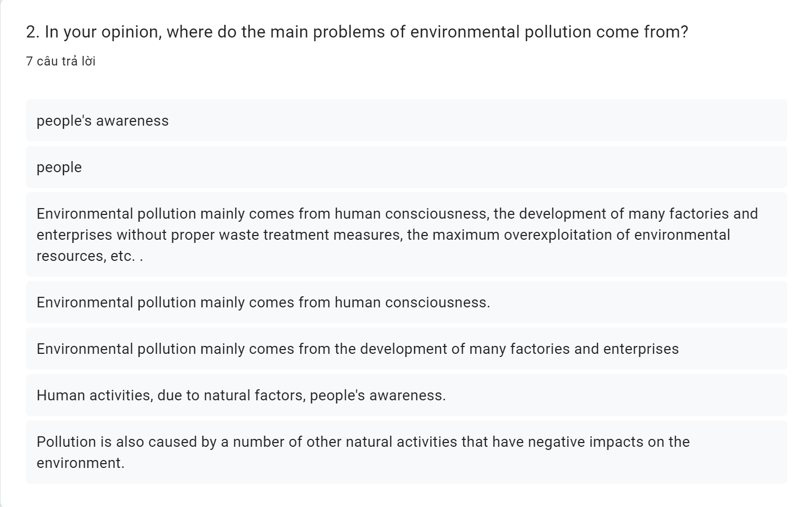

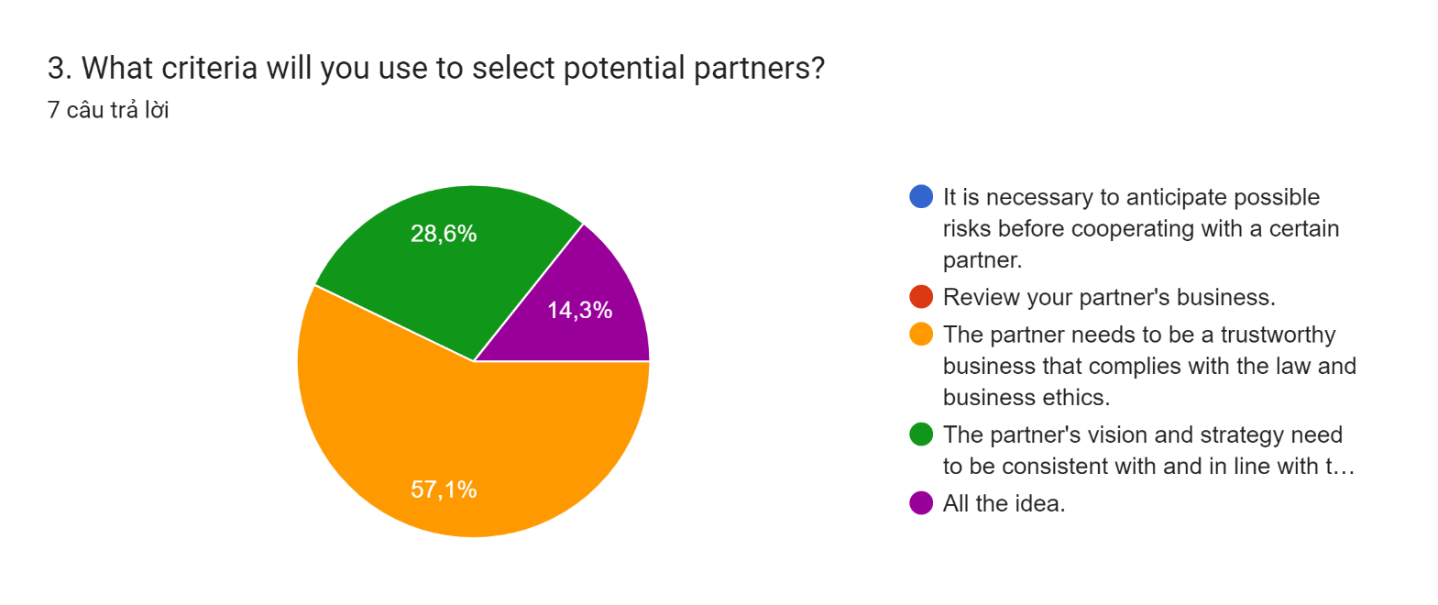

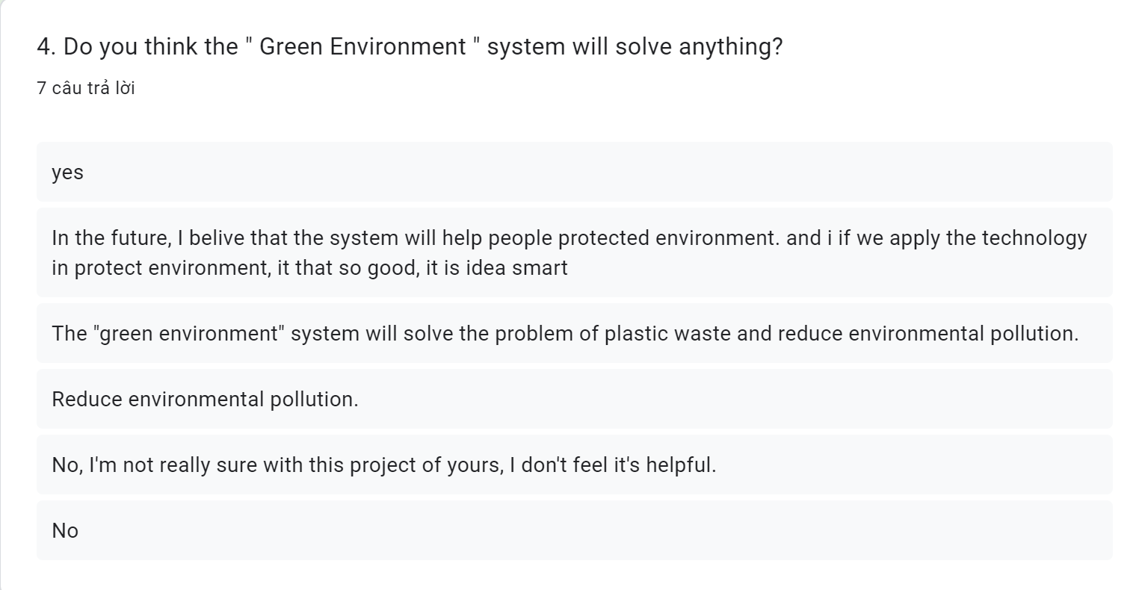

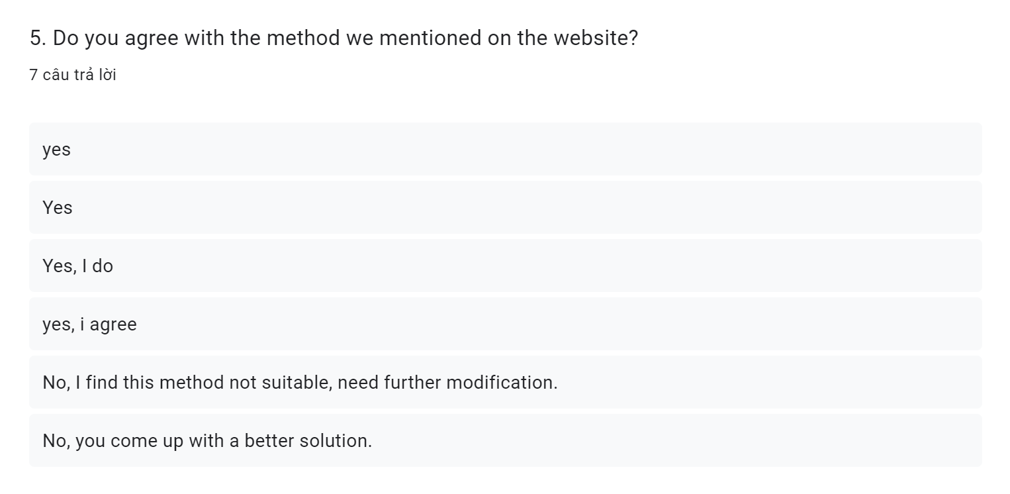

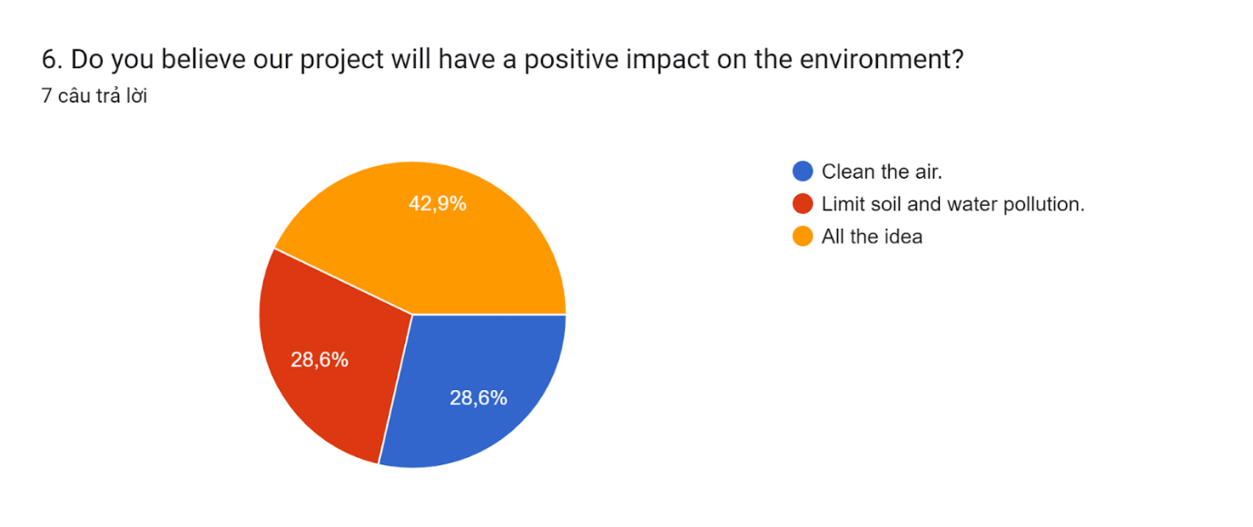

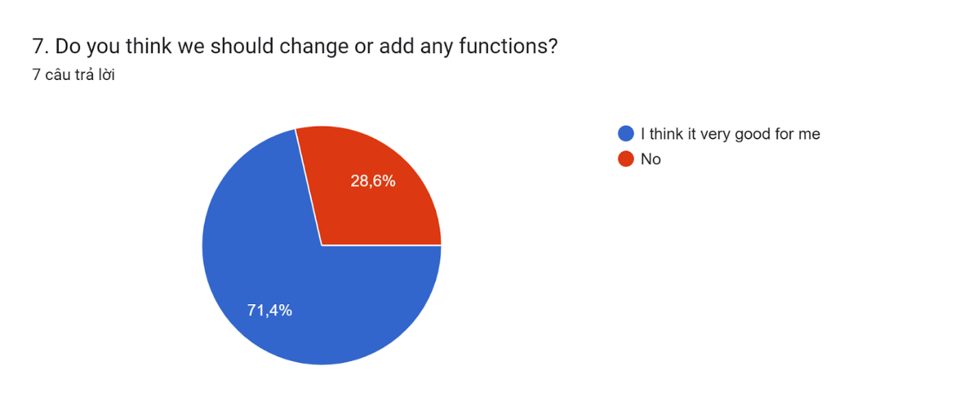

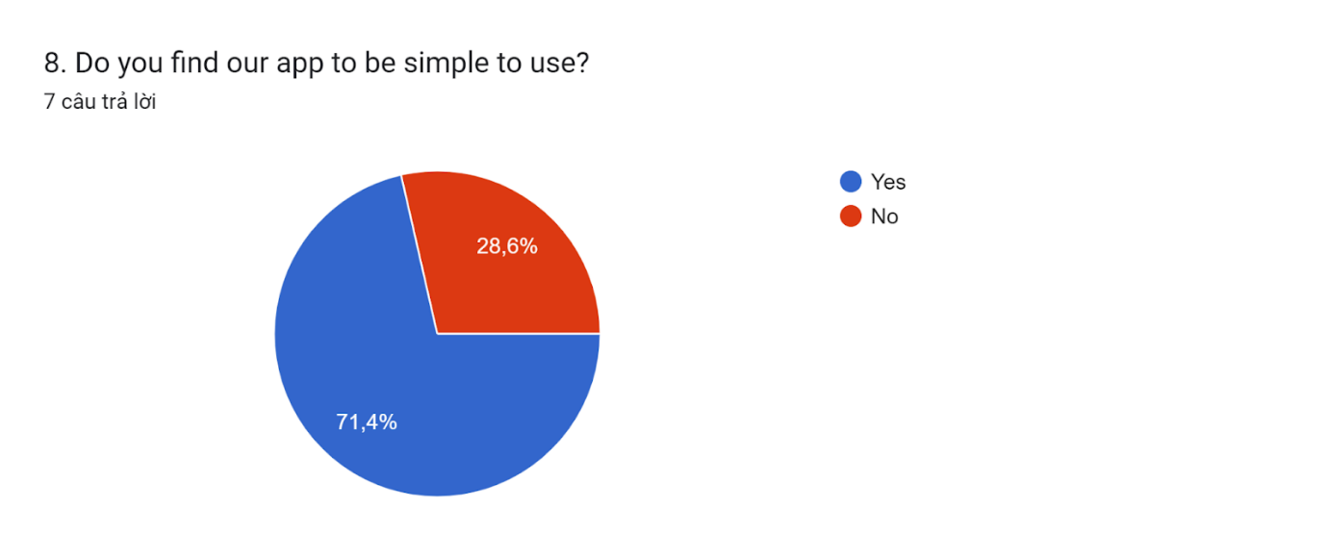

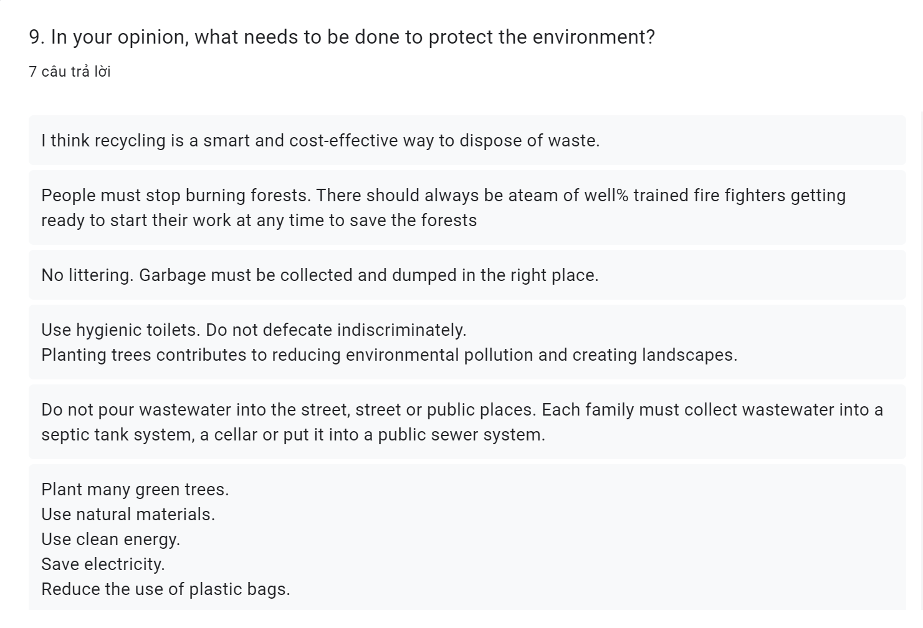

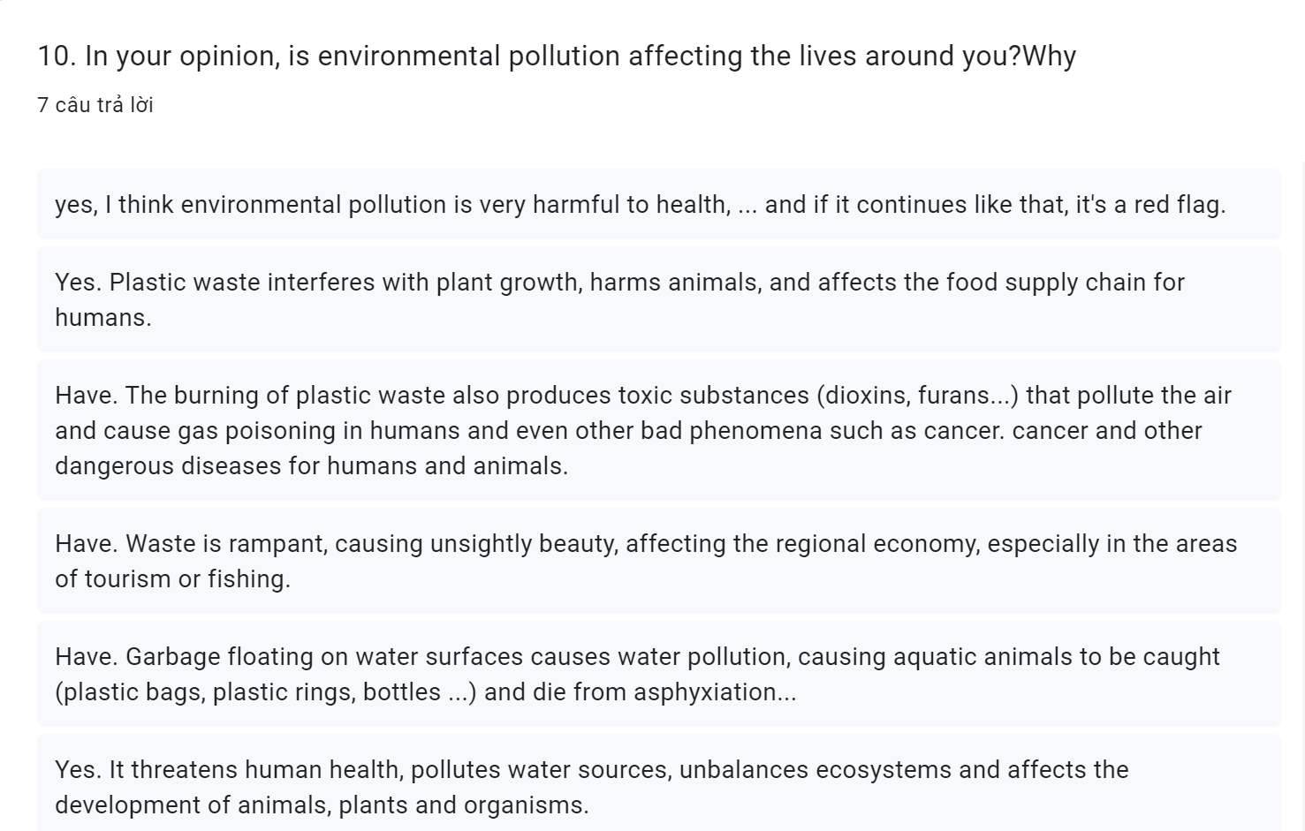

1. Findings of research

The study sought to determine whether a website that collects and recycles plastic waste can help reduce waste generation, as well as whether collecting and mobilizing people to reduce waste through the website is truly effective. A survey panel was used to conduct the research:

According to survey results, a website that collects and recycles plastic waste will significantly reduce plastic waste. According to a new OECD report (Oecd, 2022), the world is producing twice as much plastic waste as two decades ago, with the bulk of it ending up in landfill, incinerated or leaking into the environment, and only 9% successfully recycled. Almost half of all plastic waste is generated in OECD countries, according to the Outlook. Plastic waste generated annually per person varies from 221 kg in the United States and 114 kg in European OECD countries to 69 kg, on average, for Japan and Korea. Most plastic pollution comes from inadequate collection and disposal of larger plastic debris known as microplastics, but leakage of microplastics (synthetic polymers smaller than 5 mm in diameter) from things like industrial plastic pellets, synthetic textiles, road markings and type wear are also a serious concern. (Yi Zhang, 2022)Most of the respondents said that the pollution problem comes from humans. There are also some other problem.



Moreover, finding potential partners is also a very important issue. According to, Leading multinationals and conglomerates earn a good brand image through waste-management strategies. For instance, a few big companies are ranked as top environment-protecting companies. The company has delivered remarkable achievements in protecting the environment and fostering a sustainable carbon emissions footprint by reducing CO2 emissions per employee. The company prioritizes reuse and recycling. (Muhammad Farooq, 2022) When cooperating with a certain company, reliability will be a top priority. according to the LegalNature website, A good business partner must be someone whom you can trust. Everyone has their own quirks and individual ways to deal with stress, success, and failure, but if you can inherently trust your business partner, you will have a better chance of succeeding as partners. (LegalNature logo, 2023)



In conclusion, those findings support the notion that a plastic waste collection and recycling website can reduce the amount of plastic waste thrown outside, as well as collection and advocacy via the website to help people separate waste and learn more about environmental protection. The study also provides evidence that plastic waste can be effectively managed if people are more conscientious. Based on these studies, we can conclude that the plastic waste recycling website is a profitable and useful tool for promoting human environmental protection.

1. Conclusion

Overall, the development of a plastic waste recycling system is an important step towards protecting the environment. In this report, the scope, project objectives, WBS, budget, risk plan, etc. have been detailed. Furthermore, there were discussions about the project. This project will bring people a cleaner air, reduce waste and protect the environment.

# References

LegalNature logo, 2023. *Qualities to Look for When Choosing a Business Partner.* [Online]   
Available at: https://www.legalnature.com/guides/qualities-to-look-for-when-choosing-a-business-partner

Muhammad Farooq, J. C. U. K. A. S. K. a. H. A. B., 2022. *Sustainable Waste Management Companies with Innovative Smart Solutions: A Systematic Review and Conceptual Model.* [Online]   
Available at: https://www.mdpi.com/2071-1050/14/20/13146?type=check_update&version=2

Oecd, 2022. *Plastic pollution is growing relentlessly as waste management and recycling fall short, says OECD.* [Online]   
Available at: https://www.oecd.org/newsroom/plastic-pollution-is-growing-relentlessly-as-waste-management-and-recycling-fall-short.htm

Yi Zhang, Q. L. Y. Z. B. Y., 2022. *Integrated optimization of cutting parameters and scheduling for reducing carbon emissions.* [Online]   
Available at: https://www.sciencedirect.com/science/article/abs/pii/S0959652617300616?via%3Dihub